Nepal College of Information Technology
Assessment
Fall 2012
Program : BE Time : 3 hrs
Semester : Fall (VII) FM : 100
Subject : Oracle PM : 50

- Candidates are requested to give their answer as far as practicable in their own words.
- The figure in the margin indicates the full marks
- Attempt ALL question

1. (a) What do you mean by Oracle Database Instance? List the components of Memory Structure of Oracle Database instance. Describe Briefly about SGA and PGA of Oracle Database. (1+4+3)
(b) Describe the functionalities of Database Buffer Cache, Redo Log Buffer, Shared Pool and Java Pool. (7)
2. (a) What do you mean by daemon in Oracle Database? List some daemons of Oracle Database. Write functionalities of Database Writer(DBWn) and Log Writer(LGWR). (1+4+3)
(b) Name some important files of Oracle Database for its physical storage organization. (1 marks for each file name) (7)
3. (a) What is the significance of initialization parameter file in Oracle DB? Describe briefly about the type of initialization parameter files of it. (2+2[for Name] +4[Description])
(b) Describe about Oracle Enterprise Management Console (OEM), Database Configuration Assistance (DBCA), SQL Plus and iSQL Plus. (7)
4. (a) Describe the states of Oracle DB instance schematically visualizing which files are read/needed at which state. (7)
(b) Let your database is open and you are connected to database as sysdba privilege. Perform the following activities. Write SQL statement to bring database from: (8)
(i) OPEN state to MOUNT state.
(ii) MOUNT state to NOMOUNT state.
(iii) NOMOUNT state to MOUNT state
(iv) MOUNT state to OPEN state
5. (a) The schema of Department Table is given below:
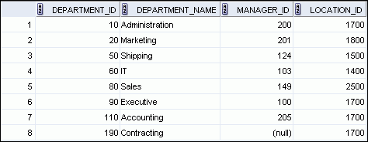

i) Write SQL statement to display the query output as given below: (4)
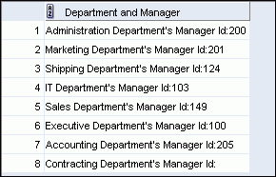

ii) Write SQL statement to display how many departments are located in one location as given below: (4)
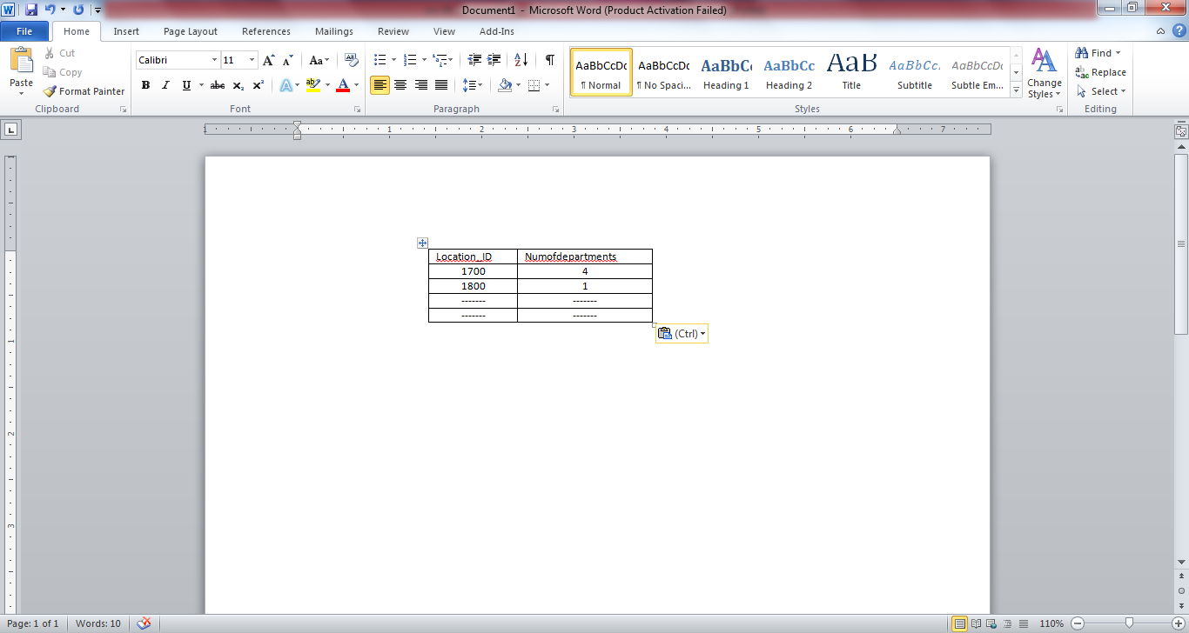

(b) A table schema is given below as:

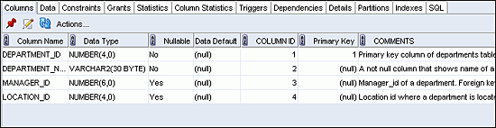

i) Write SQL statement to create table in Oracle DB. (3)
ii) Assume Department_ID is primary key of this table. Write SQL statement to define this field as primary key. (2)
iii) Assume Location_ID in this table is Foreign key references Location_ID of Location table. Write SQL statement to define that this column is foreign key of table Location (Location_ID). (2)
6. (a) Assume you have created three Oracle databases as ORCL, NCIT and DEMO databases in the same machine. You are interested to access the NCIT database with Command Prompt. How you will access the NCIT database using DOS prompt of SQL? (Hint: First set Oracle_SID in command prompt then enter into the DB by using OS authentication.) Write steps and necessary commands/statements. (7)
(b) Introduce briefly about View and Inline View in Oracle DB with appropriate example. (4+4)

7. Write short notes on: (Any two) (2x5)
(i) Features of Oracle Database 11g
(ii) ORDBMS
(ii) Sub Query
(iv) Backup and Recovery in Oracle Database

